[](https://www.google.co.uk/url?sa=i&rct=j&q=&esrc=s&source=images&cd=&cad=rja&uact=8&ved=0ahUKEwjDjvrOx73SAhWEPBQKHWOlDeEQjRwIBw&url=https://vanessajackson.wordpress.com/2012/05/06/gargoyles-in-oxford/&bvm=bv.148747831,d.ZGg&psig=AFQjCNHIjHyt9SjKcG6DLsG-LXmH_4m6Cg&ust=1488741257774159)[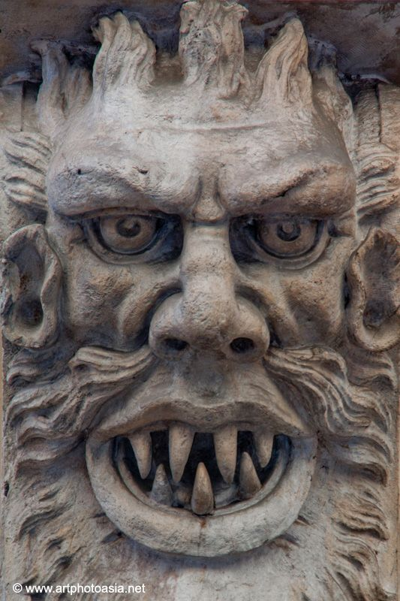](https://www.google.co.uk/url?sa=i&rct=j&q=&esrc=s&source=images&cd=&cad=rja&uact=8&ved=0ahUKEwjfsvL0xr3SAhUG8RQKHTlNCh4QjRwIBw&url=https://www.pinterest.com/pithomas/gargoyles/&bvm=bv.148747831,d.ZGg&psig=AFQjCNGN6q6nT-e0_4U97MaIoberTn9z7g&ust=1488741065020626)[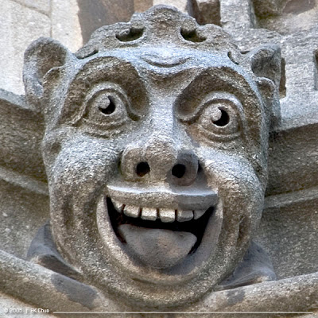](http://www.google.co.uk/url?sa=i&rct=j&q=&esrc=s&source=images&cd=&cad=rja&uact=8&ved=0ahUKEwin86_oxr3SAhXBvhQKHQQrBSwQjRwIBw&url=http://www.darkroastedblend.com/2011/05/gargoyles-grotesques-part-2.html&bvm=bv.148747831,d.ZGg&psig=AFQjCNGN6q6nT-e0_4U97MaIoberTn9z7g&ust=1488741065020626)[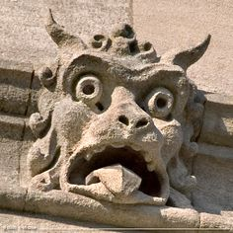](https://www.google.co.uk/url?sa=i&rct=j&q=&esrc=s&source=images&cd=&cad=rja&uact=8&ved=0ahUKEwjg9eyyxr3SAhXIXRQKHSaDCNcQjRwIBw&url=https://www.pinterest.com/pin/291467407105443242/&bvm=bv.148747831,d.ZGg&psig=AFQjCNHR8Ul6vMzHwjc2hrnluWyEU1dIJg&ust=1488740815599327)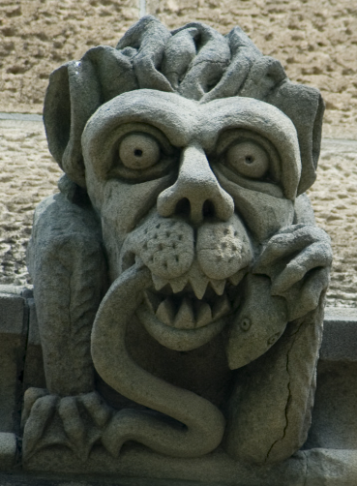[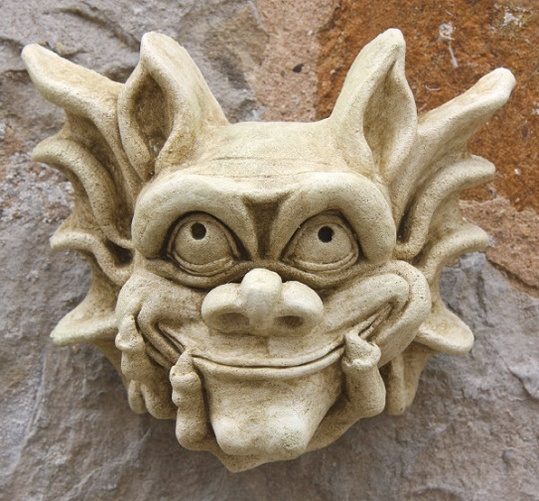](http://www.google.co.uk/url?sa=i&rct=j&q=&esrc=s&source=images&cd=&cad=rja&uact=8&ved=0ahUKEwikheLLxr3SAhUD6xQKHQNxCigQjRwIBw&url=http://abbysartportfolio.weebly.com/gargoyles-research.html&bvm=bv.148747831,d.ZGg&psig=AFQjCNHR8Ul6vMzHwjc2hrnluWyEU1dIJg&ust=1488740815599327)[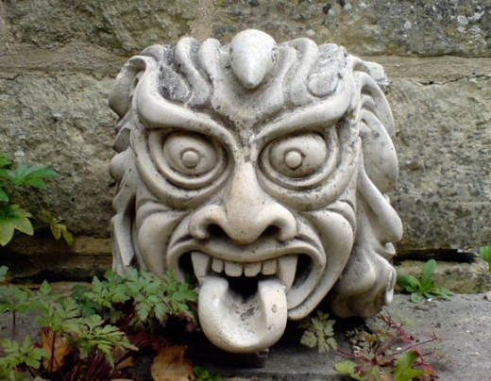](https://www.google.co.uk/url?sa=i&rct=j&q=&esrc=s&source=images&cd=&cad=rja&uact=8&ved=0ahUKEwiy6NC7xr3SAhUDtxQKHayuBFsQjRwIBw&url=https://www.pinterest.com/ovolynsky/gargoyles/&bvm=bv.148747831,d.ZGg&psig=AFQjCNHR8Ul6vMzHwjc2hrnluWyEU1dIJg&ust=1488740815599327)[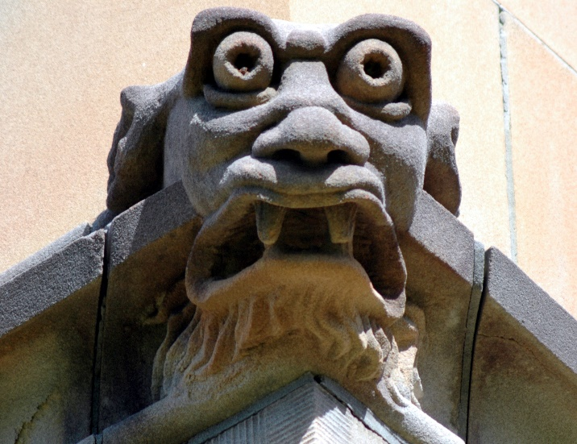](https://www.google.co.uk/url?sa=i&rct=j&q=&esrc=s&source=images&cd=&cad=rja&uact=8&ved=0ahUKEwjZ-LTfxb3SAhXMNxQKHaBxCSQQjRwIBw&url=https://www.tes.com/lessons/MtFJO0F5dM6nqA/1-gargoyle&psig=AFQjCNGfzrgU27BJSuYm9GGL3lJf8YfQhA&ust=1488740783831769)