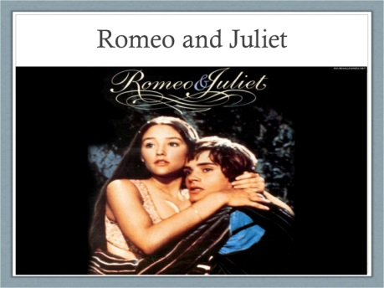

Romeo and Juliet Writing Assessment
Imagine you are a coroner writing the formal written report to Prince Escalus concerning the death of Romeo and Juliet. A coroner is a person who investigates why someone has died. They decide if it was for example a murder, a suicide or death by natural causes. You need to look at the evidence surrounding their deaths and decide which of the reasons it was. Also, you should say what events led up to their deaths.
To help you do this you should include the following:
Paragraph 1 – A short introduction, which includes the 5Ws (who was involved/at the scene, where the bodies were discovered, what was found there, when they were discovered, and why you are writing the report (to decide the cause of death and give recommendations to avoid this happening in the future.)
Paragraph 2 – The background. Explain which families the couple belonged to and mention the longstanding feud.
Paragraph 3 – The sequence and chain of events leading up to the death. For example: the secret wedding; Mercutio and Tybalt’s deaths; Romeo’s banishment; Paris and the wedding etc.
Paragraph 4 – The scene of the death and its immediate impact. What was discovered at the scene and what it appears happened. What do the forensic teams think caused each death?
Paragraph 5 – Your verdict, conclusions, recommendations and any advice to take on board in the future. Give your verdict (decision) about what caused the two deaths based on the forensic evidence. Summarise what actions can be taken to avoid this happening again to others in the future. (To ensure families don’t feud etc.)

90-95 | 100 | 105
I can describe how things happened.  My writing is organised into ideas.  I usually use capital letters, full stops and question marks.  I can extend sentences with  different conjunctions.  I can understand the meaning of purpose and audience. I can use a formal tone.  I can use some of the right features for the purpose. | I match my language choices to the purpose and audience. (Formal tone, technical vocabulary)  I can extend sentences with  a variety of conjunctions.  I can paragraph my work.  I link paragraphs with suitable phrases e.g. adverbials/conjunctions etc.)  I can use a range of punctuation, including commas, semi-colons and apostrophes.  I can show evidence of improvement in my writing.  My vocabulary is precise and imaginative. | I can use a range of sentence structures and varied vocabulary to create effect.  I can understand and use a range of words appropriately.  I can use formal language and jargon.  I can use a range of punctuation, including commas, semi-colons, colons and apostrophes.  I always paragraph my work. I use the correct connectives to link ideas or paragraphs.  I can write complex sentences with embedded clauses or phrases.  I can often sustain the interest of my reader.

WORD BANK/Technical Vocabulary:
The following words could be useful in your report:
feud
toxicology report
apothecary
poison
forensics
investigation
evidence
verdict
crime scene investigators
deceased

