Read the letters from Cavalryman Jacob Siward and complete the activities below.
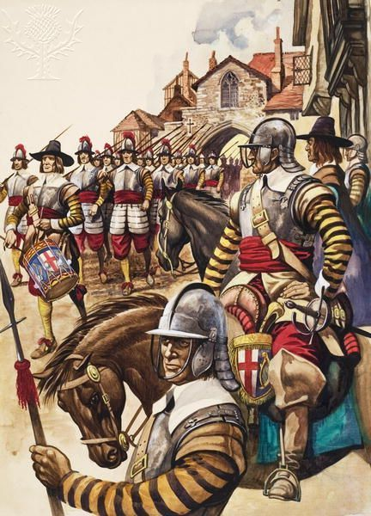
A group of pikemen of the New Model Army march into battle led by a drummer (gouache on paper) / Credit: Private Collection / Look and Learn / Bridgeman Images / Copyright © Bridgeman Images / For Education Use Only. This and millions of other educational images are available through Britannica Image Quest. For a free trial, please visit www.britannica.co.uk/trial

24th October 1642
My dearest wife Mary,
I write by candlelight to tell you that I am well and have survived a fearsome test where near 3,000 others around fell me to the brutal sword of our disgraceful King’s army. God be praised! We had marched to Edgehill because we had heard that the King had massed his troops for a march on London. If London had fallen to the King, our cause would have been lost! And yet, thanks to our Lord God’s sustaining help, we, under our great commander the Earl of Essex, managed to stop the King’s progress. We are lucky that our Earl is such an experienced soldier, while the King relied on the help of his young and reckless nephew, Prince Rupert. We heard that the young Prince argued fiercely with King Charles’s commander-in-chief the Earl of Lindsey and that Rupert decided to disobey his orders. How happy were we that the young Prince’s cavalry – a huge force on horses – did not follow the Earl of Lindsey as he attacked our foot soldiers!
Stay true to me, dear heart, and kiss our children for me.

19th August 1643
My dearest wife Mary,
My heart is sore troubled by our long absence and I am happy that you have managed to run our home and farm so well without me. When I last wrote, from Gloucester, you will remember how afraid I was that the King was so doing so well and our numbers in the field dwindling to so few. Though we still hold London, we were becoming worried that we may soon run out of men. You will be as relieved as I am then to hear that our godly friends in Parliament have succeeded in bringing a new Impressment Ordinance into being, a law that gives our Parliamentary army the right to conscript men into our ranks. Yes, just three days ago, our humble ranks were swelled by the arrival of 65 good and strong men from the villages around Banbury. They did groan and complain, as they had hoped to avoid such bloody war, but we share the same dislike of our treacherous King’s wicked ways and are truly glad to have them with us.
Remember to organise help for the harvest as soon as possible – with so many men now away fighting, you may struggle to make do with the ancient and young!

12th September 1643
Wonderful news my dear Mary!
We have heard from a reliable source that just last month our King’s Scottish subjects signed an agreement with our godly Parliament which means that they will be sending their army, known as the Covenant Army, to our aid! We all know from bitter past experience how fierce these Scots can be – and yet now they will fight on our side! There is no love lost between the Covenanters and the King. They are as despairing as we are about our terrible king. London still holds for us. I cannot write more: we are on the march again.

24th July 1644
My love, my own Mary
I wish you to hurry to the church and pray with true and deep thanks that our Lord chose to spare both me and our glorious army as we faced the wrath of our King’s strongest force on the outskirts of York, in the moors at Marston. May it be that Marston Moor becomes known as the most important battle of this cruel and terrible war. It was the first time that I had fought alongside our brother soldiers from the north: the fearsome Scottish Covenanter Army. Though a mighty foe from our nation’s past, yet now we share an unbreakable bond as we crushed the king’s forces from both north and south. I must tell you as well that we were blessed by the arrival of a powerful cavalry force from East Anglia. We nicknamed them the ‘Ironsides’ because their horses stood so firm against the worst attacks of the King’s men. Their commander too, a man called Oliver Cromwell, was as strong as iron in his command. God be praised, that he saw fit to stir up such warriors to oppose that tyrannical lord, Charles.

25th February 1645
Dearest Mary,
I write with joy in my heart as we have had more good news! Cromwell – we call him our chief of men – has managed to persuade Parliament to set up a wonderful new army which he has called the New Model Army. My regiment will be joining it within the next two weeks! At last, we will be paid regularly so I can send you money without having to wait and hope. In this we will be so much happier than the King’s soldiers. We hear that some have not been paid for over 6 months and are having to steal from fields and villages just to survive. Not us! The New Model Army will be well paid and well supplied and each regiment will be equipped with its own uniform so we can recognise each other on the battlefield. London still holds.

17th June 1645
Prepare a feast, my dear Mary, as I am finally on my way home! Although the King brought his entire forces, collected from all parts of these British Isles onto the battlefield against us, yet with the New Model Army battalions we outnumbered him outside Naseby by nearly two to one. Once again we benefitted from the King’s chaotic military planning as he listened first to Lord Digby and then – with opposite advice – to his nephew Prince Rupert, finally deciding to follow Digby’s advice. What disorder! What poor thinking! Under brave Cromwell, with our soldiers singing from the Bible Psalms as we marched out, we knew that God was on our side, our bodies well fed, our orders clear and so, who could stop us! Not the King, as his army was destroyed! I hope to leave and be on my way to you within a week.

3rd July 1645
Dear heart,
I am sorry to say that I was too optimistic about how quickly this war would be finished. It is true that we have destroyed the King’s army and yet some few of his commanders fight on in the further regions. London still holds for our side and I have been despatched towards Bristol to which Prince Rupert has fled. I will write from there.

28th April 1646
Mary,
It is over at last. The King, fearing our army as we advanced on his headquarters at Oxford, has surrendered himself to the Scots. Of course, our friendship with the Scottish Covenanters stands firm, so we expect that he will be transferred shortly to us. My commander has agreed that, my long service having been so great, I can now, finally leave and return to you. I will be with you before our Sabbath-day Sunday.
I bid you farewell.

Activities
- Read the letters carefully. Identify as many reasons as possible for the King’s defeat and the Parliamentarians’ victory.
- What do you think are the most important reasons for Parliament’s victory?
- Create a timeline for the key events of the English Civil War (using months and years only).

Extension: write alternative diary entries from a royalist soldier.

